COEN 161 Web Programming 1 Fall 2014

Lab 3 100 pts
TA: Wenliang Tong Email: wtong@scu.edu
Office hrs: Tues: 8.15AM-9.15AM and Fri: 1.15-2.15pm

Objectives:

- Learn to use CSS positioning to move elements from their normal position in the document using relative and absolute positioning.
- Use JavaScript random() function to generate a random function in a desired range.

Extract the zipped file, lab3 into lab3 folder.

Exercise 1 (15 pts)
Open the file, PostionExercise1.html in FireFox or Chrome. You should see red, yellow and green boxes, stacked vertically.
We want to move the middle (yellow) box to the right (from its current position) by 50 px and drop down by 50 px.
Save the PositionExercise1.html as PositionExercise1A.html. Add the following style rules to box2 in this file.
position: relative;
left: 50px;
top: 50px;

View the file again in the browser. Did the yellow box move as you intended?
No the yellow box shifted over the green box
The 50px offsets (both top and left) are measured from the original position of the yellow box. Note too that the red and green boxes did not move, that is because, as far as they are concerned, the yellow box is still in its starting position—in other words, they ignore the positioning of the yellow box, which allows the yellow box to overlap the green box.
Relative position is close to floats in how they work. They can be moved around using either the top, right, left, bottom rules or by margins like floats can. Relative positioning changes the element without influencing the layout of other elements.
Now, do the following changes to PositionExercise1A.html.
- We want add some text content to the boxes. Copy some text from fillertext.txt and paste into the three divs.
- Remove the line, height:100px from .box.
View the file again in the browser. Are the positions of boxes similar to the ones without text?
Yes they are similar except larger because of all the text.
Exercise 2 (15 pts)
View the file, PositionExercise2.html in FireFox or Chrome. You should see red, yellow and green boxes, stacked vertically, in a gray container. Examine the styles. Save the file as PositionExercise2A.html.
Change the styles in PositionExercise2A.html to move the boxes as shown below. Use only relative positioning as we have done in Exercise 1.
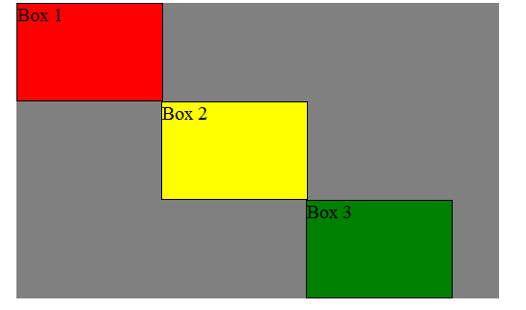

Exercise 3 (15 pts)
In this exercise, you will practice absolute positioning of elements on the page.
Absolute positioning removes the element from the document flow altogether. The other elements around it will move together and act as if the absolute positioned element never existed.
In other words, when you position an item absolutely, you remove it from the flow of the document, causing the elements that follow it collapse up and/or over, closing the gap.

Open the file, PositionExercise3.html. You will see our red, yellow and green boxes, stacked vertically.
We want to move the Yellow box 20px from the bottom of the container and 50 px towards right.
To accomplish this, add the following styles to #box2.
position: absolute;
left:50px;
bottom: 20px;

View the results in the browser. Did we accomplish what we wanted?
No the yellow box completely disappeared.
Since, the yellow box is moved out of the flow of the document, the green box slides over, up against the red box, filling in the area previously occupied by the yellow box (box2).But where is the yellow box?
It ended up 20 px from the bottom and 50 px from left of the browser window and not its parent container.
The absolutely positioned elements are positioning themselves in relation to the body element instead of their direct parent, because their direct parent (#container div here) is not positioned.
Now add the following rule, to #container.
position: relative;

View the results in the browser. Did we accomplish what we wanted?
Yes we accomplished what we wanted
Exercise 4 (20 pts)
The z-index property specifies the stack order of an element. When elements overlap, z-order determines which one covers the other. An element with a larger z-index generally covers an element with a lower one.
NOTE: z-index only works on positioned elements (position:absolute, position:relative, or position:fixed).
Usage: z-index: 500;

Example:
Suppose you give each element you want in your stack a different z-index value. For example, if I have five different elements:
•element 1 — z-index of -15
•element 2 — z-index of 100
•element 3 — z-index not set
•element 4 — z-index of 10
•element 5 — z-index of -3

They will stack in the following order:
1. element 2
2. element 4
3. element 3
4. element 5
5. element 1

- Open the file, Z-indexExercise.html in the browser and in a text editor.
Change the z-index of the images such that the blue and yellow images are shown on top of the bricks image.
- Open the file, Exercise4.html. You will see the page with boxes as below:
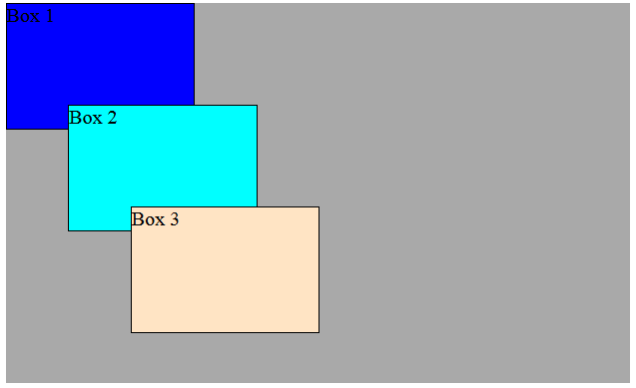
Now edit the styles so that the boxes are displayed as below.
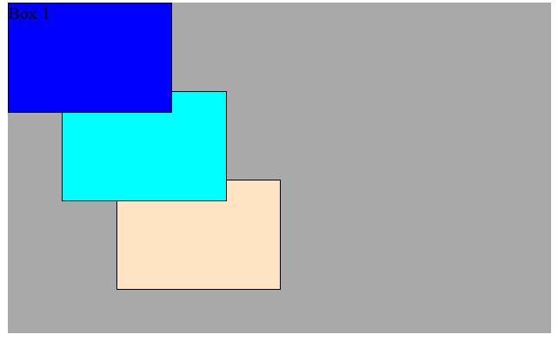
Exercise 5 (10 pts)
The webpage with styles is given below. Its rendering in the browser is shown in a), which shows the normal flow of the blocks.
<style>
.box {width: 300px; padding:10px; border: 1px solid black}
#container {width: 650px; padding:10px; margin: auto;
border: 1px solid black; }
</style>
</head>
<body>
<div id="container">
<div class="box" id="one">One</div>
<div class="box" id="two">Two</div>
<div class="box" id="three">Three</div>
<div class="box" id="four">Four</div>
</div>
a)
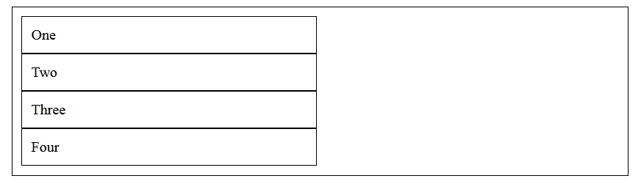
b) We want the blocks positioned as shown below. Make the required changes to the stylesheet given below to accomplish it.
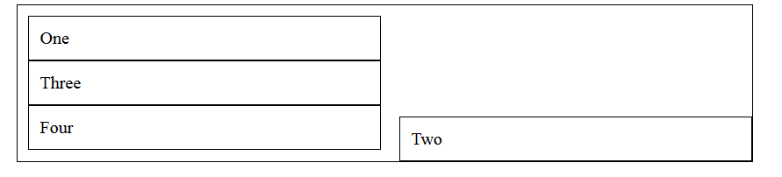
<style>
.box {width: 300px; padding:10px; border: 1px solid black}
#container {position: relative; width: 650px; padding:10px; margin: auto;
border: 1px solid black; }
#two { position: absolute; right:0px; bottom: 0px; }
</style>

Exercise 6 (10 pts)
Open the file,Q6,html in Chrome browser. The side columns seem equal in height with the middle column, even though the middle column has content longer than the side columns.
Examine the code and write below the reason the side columns seem to be the same height as the middle column.
The section element of sect 2 clears all other elements above it so the other two colums are just lengthened down
Exercise 7 (15 pts)
This question will require you to examine the JavaScript code given in the html file and do the necessary modifications as described below.
Open the file,showRandomNumber.html in the Chrome browser. Click on the button with the label, Show a Random Number.
What number does it show?
0
Click on it a few times.Does it show a number different from the first time?
Nope
We want this program to show a random number between 0 and 100 when the button is clicked. You may have to modify the formula given to calculate a random number in the range 0 to 100.
Open the file,showRandomNumber,html in the text editor. Examine the code.
Refer to this link on random() function JavaScript, http://www.w3schools.com/jsref/jsref_random.asp
Now make the necessary changes to the code in getRandomNumber() in the given HTML file.
Test your code by opening the file in the browser and clicking the button a few times. Make sure that a random number is generated (every time you click the button) in 0 – 100 range.

